Student Name | G. Manasa
Student Registration Number | 241U1R3007 | Class &Section: CSE(DS)
Study Level: UG/PG | UG | Year &Term: I & II
Subject Name | Digital Electronics

Name of the Assessment | Reflective Journal -7
Date of Submission | 24-08-2025

Reflective Journal Template
Journal Entry Guidelines | Description
1. Experience (Class Content) | Briefly describe the topics or concepts discussed during the class.
2. Feelings (Emotional Reactions) | Share your emotional reactions and thoughts during the class.  How did you feel while learning this theory?  Did the class evoke specific emotions or questions?
3. Learning (Key Insights) | Reflect on what you learned from the class.  Highlight the key insights or fundamental concepts you gained from the class.
4. Application (Practical Use) | Describe how you plan to apply the theory you've learned in real-life situations or in your academic/career endeavours.  Explain the practical utility of this theory.

Sample Journal Entry

Date | 24-08-2025
Journal Entry Topic | Combinational Logic Design-II
1. Experience (Class Content) | In this module I got the chance to learn about some very important topics in digital electronics: code converters, comparators, multiplexers, demultiplexers, encoders, and decoders. At the beginning, it felt like there were too many new terms and circuits to remember. I was honestly a little nervous because each circuit had its own truth tables, Boolean expressions and diagrams. But as the classes went on I started to understand the logic behind each one.  The experience was like solving a puzzle. Every time I looked at a truth table or a circuit diagram, I felt like I was unlocking a new part of the puzzle. When the teacher explained step by step with examples of where these circuits are used in real life it became more interesting. For example when I realized that multiplexers are used in communication systems and decoders are used in displays I immediately connected the topic with daily life gadgets. I also enjoyed practicing the truth tables and logic equations. At first I made small mistakes especially with expressions and K-map simplifications but later I got better. The module gave me confidence that with patience and practice even a topic that looks tough in the beginning can become manageable.
2.Feelings (Emotional Reactions) | At the beginning, I felt nervous and even a little lost because the terms seemed too technical. But once I understood that each circuit has a purpose Like a translator, selector, distributor, or converter I felt more confident. I was happy when I could solve the outputs of a multiplexer or decoder correctly. Overall I experienced both challenge and excitement challenge in understanding the logic and excitement when I finally understood it.
3. Learning (Key Insights) | 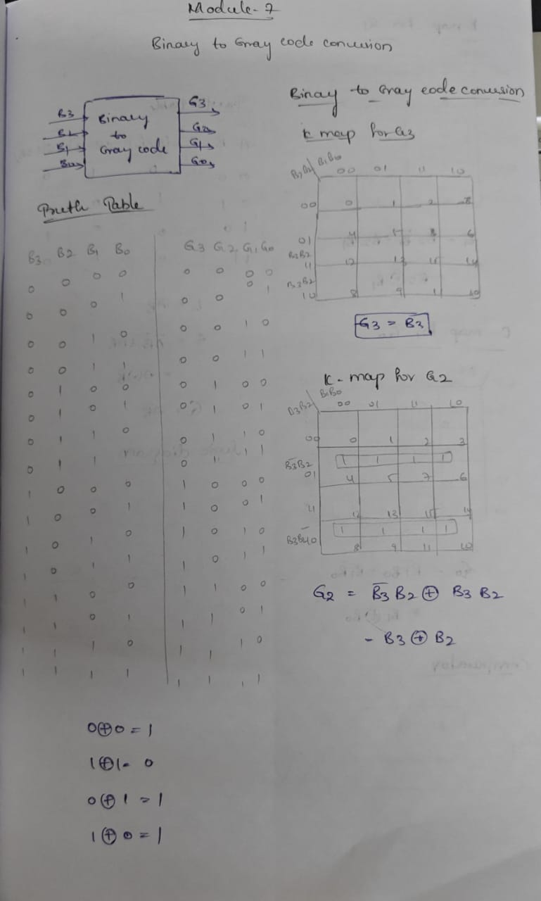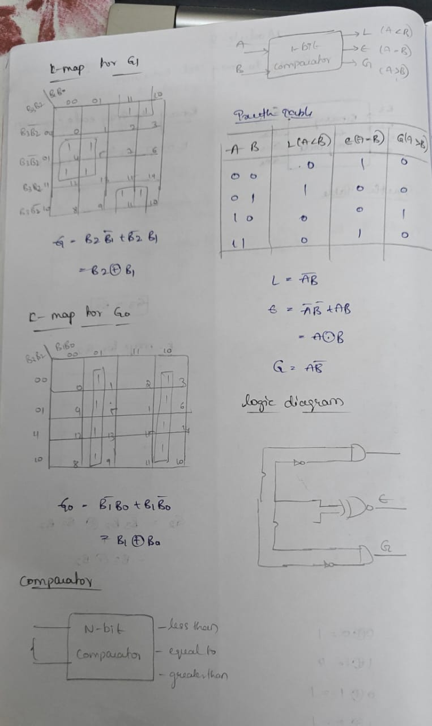  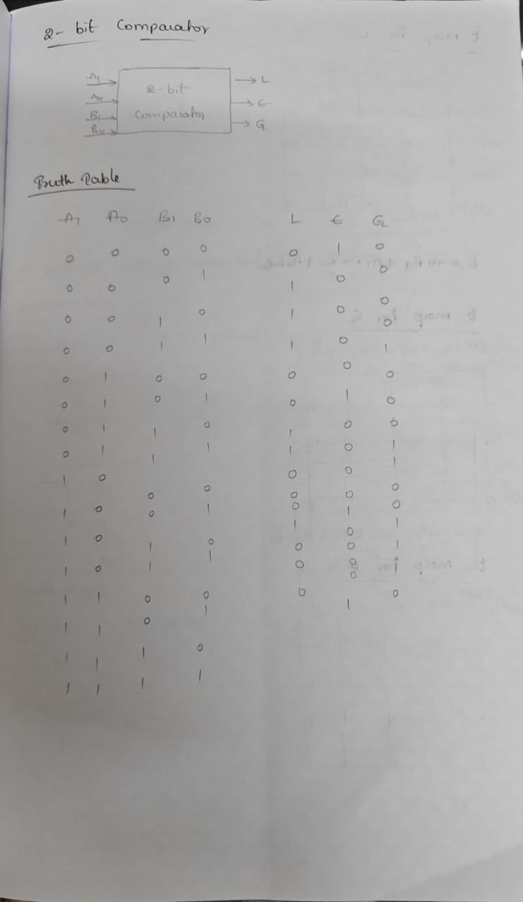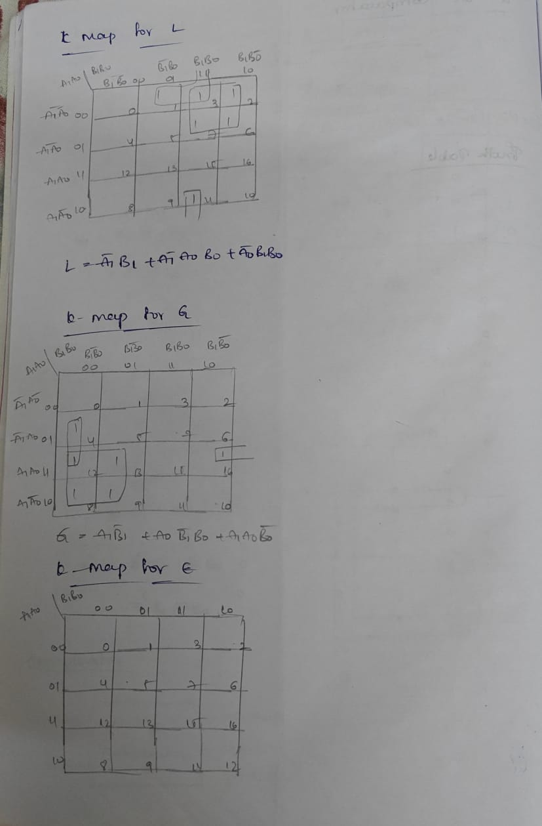  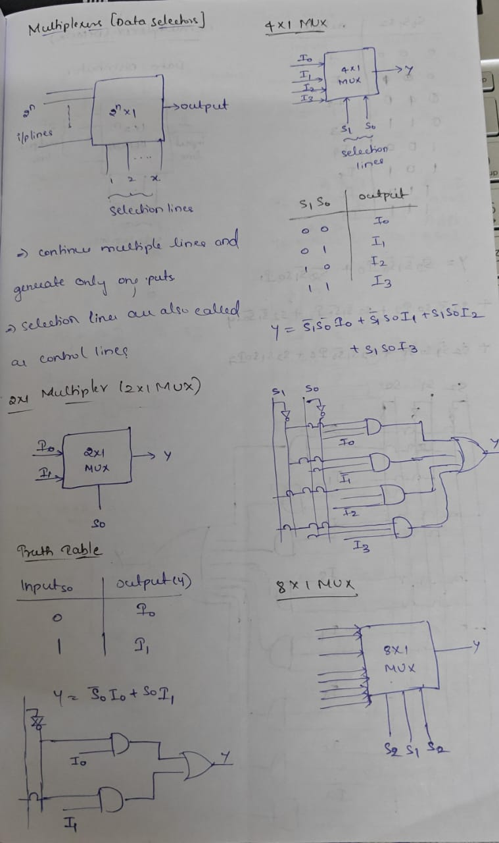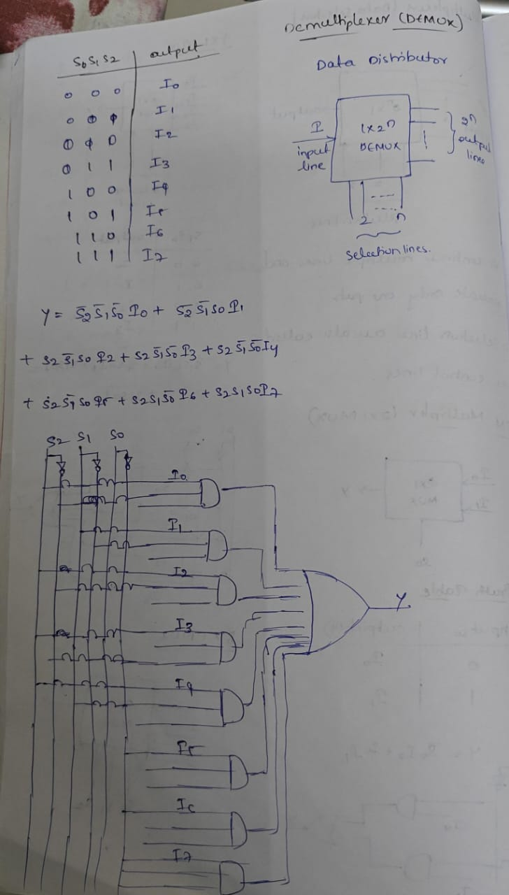  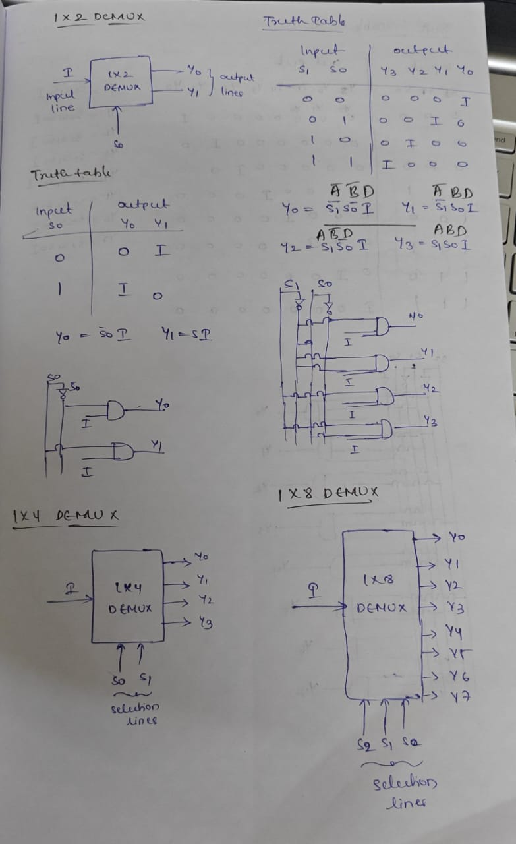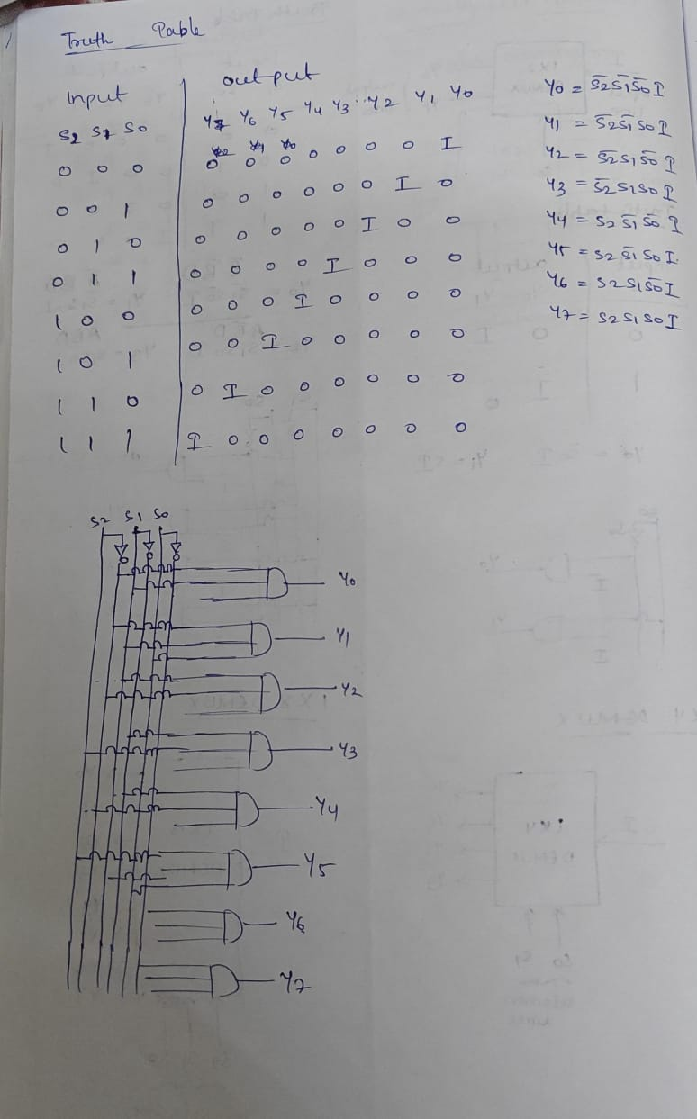  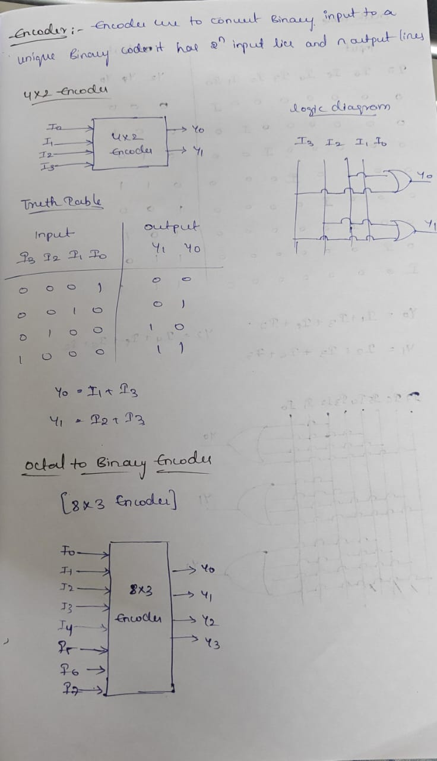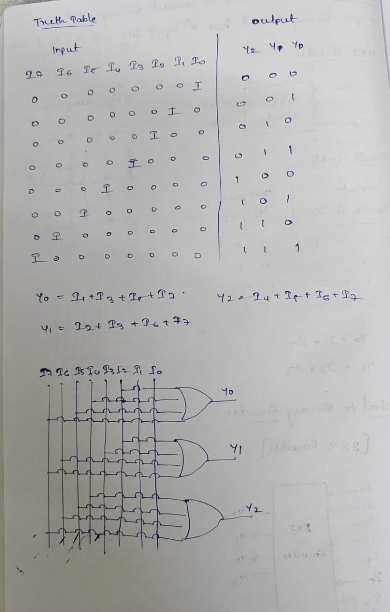
4. Application (Practical Use) | One of the best parts of this module was realizing how these concepts are applied in real-world devices.  - Code Converters: Used in calculators, digital watches, and data transmission systems. For example, converting decimal numbers to binary form inside a calculator.  - Comparators: Used in digital thermometers (comparing temperature values), in sorting devices, and also in microprocessors.  - Multiplexers: Used in data communication to send large amounts of data efficiently, in computer memory for selecting data, and in telephone networks.  - Demultiplexers: Used in communication systems to send a single signal to multiple users, and in TV broadcasting.  - Encoders: Used in keyboards, sensors, and remote control systems where input signals are converted to binary form.  - Decoders: Used in 7-segment displays, digital clocks, calculators, and microprocessor memory systems.
Conclusion | In conclusion, my experience with this module was a journey from confusion to clarity. At first, I was nervous because the concepts looked difficult. But as I practiced more and connected the topics to real life I felt motivated and confident. The key learning was that combinational logic circuits are the building blocks of digital electronics. Without these circuits, devices like calculators, computers, mobiles, and even digital clocks would not function. This module also taught me a life lesson even complex problems can be solved step by step with patience and practice. I realized that learning digital electronics is not only about theory but also about applying logic to real-world systems. Overall I feel proud of myself because I understood the importance of code converters, comparators, multiplexers, demultiplexers, encoders, and decoders. These are not just topics in my syllabus but practical tools that make our modern digital world possible.

